Gamification of Data

***Software Requirement Specifications***

**Senior Design Project - CIS 4951 - Fall 2019**

**Version No. 1.0**

Team 1

Team Members:

Ryan Ross (Team Lead)

Cameron Kozan

Zaid Alsafi

Alex Navarre

**Project Document Revision History**

|  |  |  |  |
| --- | --- | --- | --- |
| Version Number | Date | Revising Author | Description of Revision |
| 1.0 | 10/16/2019 | Ryan Ross | Document Created |
|  |  |  |  |

|  |
| --- |
| **Table of Contents** |

**1.0 Introduction/Overview** **5**

1.1 Goals and Objectives 5

1.2 Statement of Scope 5

1.2.1 Inputs 5

1.2.2 Processes 5

1.2.3 Outputs 5

1.3 Software Context 5

1.4 Major Constraints 5

**2.0 Usage Scenario** **6**

2.1 User Profiles 6

2.2 Use-Cases 6

**2.3 User Interface** **6**

**3.0 Data Description** **6**

3.1 Data Description 6

3.1.1 Data Objects 6

3.1.2 Relationships 7

3.1.3 Complete Data Model 7

3.1.4 Data Dictionary 7

**4.0 Functional Model and Descriptions** **7**

**5.0 Behavioral Model and Descriptions** **8**

**6.0 Restrictions, Limitations, and Constraints** **8**

6.1 Hardware/Software requirements 8

6.1.1 Hardware 8

6.1.2 Software 8

6.2 Inverse Requirements 8

**7.0 Validation Criteria** **8**

7.1 Classes of Tests 8

7.2 Expected Software Response 8

7.3 Performance Bonds 9

**8.0 Appendices** **9**

8.1 System Traceability Matrix 9

8.2 Product Strategies 9

8.3 Analysis Metrics to be Used 9

8.4 Development Phases 9

8.5 Deliverables 9

8.6 Example Screens/Reports 9

8.7 Report Format and Editorial Quality 9

8.8 Supplementary Information 9

**9.0 Signatures** **10**

# 1.0 Introduction/Overview

## 1.1 Goals and Objectives

To create a webpage for companies to present easily digestible data for their employees to view and track metrics. The purpose of this is to create a friendly and competitive environment where workers will be motivated to change and develop better behaviors and practices determined by the company.

## 1.2 Statement of Scope

### 1.2.1 Inputs

* Login Info
* Employee Data
* Weight values

### 1.2.2 Processes

* Retrieve data from database
* Verify login
* Choose user view
* Apply score weight

### 1.2.3 Outputs

* Display user view
* Display employee leaderboard
* Display employee specific information

## 1.3 Software Context

We are to create a webpage where employers and employees that can view statistics about their performance. The webpage will display a dashboard that allows users to view statistics and provide a login panel. Users will see a different view depending on their account level. An employee will see data about their own performance. A manager will be able to see the statistics of the employees under them. The Admin will be able to see the statistics of the managers and their teams below them, along with seeing the overall stats of the company. The admin will be allowed to change the weight of each field to adjust the leaderboard based on the significance of the weight.

This data will be gamified so that the employees will be encouraged and engaged with the application along with being motivated to do their job better. The core concepts of gamification that will be implemented are as follows: Points, Badges, Levels and Challenges. Points will be determined by the managers and the weights of each item. Points will numerically represent the user’s progress. Badges are to show off a user’s achievements. Levels are to motivate users (Individual employees along with teams) to increase their efforts to achieve a progressively higher level. Challenges, which can vary from very simple to very complex, are tasks that often require involvement of an entire group of users but can be targeted to a single user as well. We also consider leaderboards a key part of gamification, to allow users to seek how they are doing among their peers.

## 1.4 Major Constraints

* Time
* Availability of the Team and owner
* Accessibility of previous project artifacts
* Limited knowledge of used technology

# 2.0 Usage Scenario

## 2.1 User Profiles

* Owner of a company
* Employees at a company
* Managers at a company

## 2.2 Use-Cases

* An owner of a company can see the stats of all the workers.
* An admin of the company can adjust the weight of each field to shift the leaderboards.
* An admin of a company can see the workers who cost them the most money.
* Employees
  + See how they rank among colleagues
  + See how they can improve
  + See statistics about their performance over a span of time

# 2.3 User Interface

* There will be three different user interface views: Administrator, Manager, & Employee
  + Administrator: Displays full access to Manager and Employee views
    - Allows the user to edit weights and costs for tools
    - Displays all manager and employee scores and statistics
  + Manager: Allows user to edit individual employee scores
  + Employee: Only displays individual score and leaderboard
* User interface will be displayed using a webpage

# 3.0 Data Description

## 3.1 Data Description

### 3.1.1 Data Objects

* Truck
  + Truck ID #
    - Unique identifier for each truck entity
  + Tool List
    - List of tools associated with each truck
* Tools
  + Tool ID #
    - Unique identifier for each tool entity
  + Weight
    - A weight that assigns a value to determine scoring
  + Cost
    - Cost for each tool entity
* Employees
  + Employee ID
    - Unique identifier for each individual employee
  + Company
    - Company that the employee works for
  + Name
    - First and Last Name
  + Credentials
    - Account level: Admin, Manager, Employee
  + Score
    - Predetermined scored

### 3.1.2 Relationships

* Trucks are associated

### 3.1.3 Complete Data Model

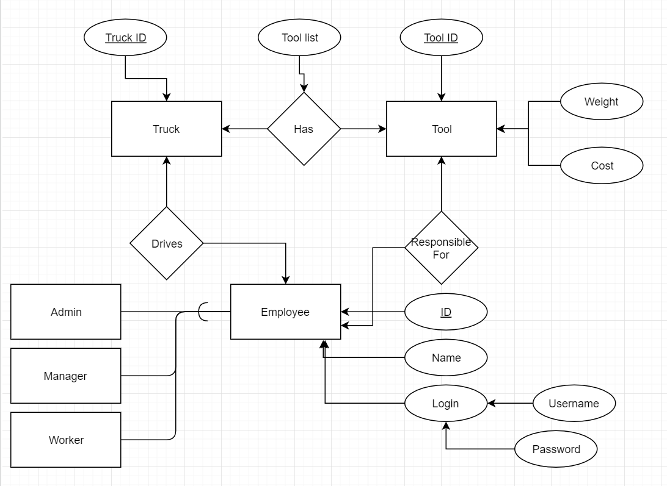

### 3.1.4 Data Dictionary

[Data Dictionary](https://drive.google.com/a/umich.edu/open?id=1BSthEYRJ4UToakAJaAybwV7Vkfm9VXL56EBH70JQ-3k)

# 4.0 Functional Model and Descriptions

* Record and store employee tool data
* Record and store truck data
* Retrieve data from outside database
* Track employee performance metrics
* Provide visual representation for data
* Display information using a webpage
* Login system with hierarchy
* Provide different user views depending on login credentials
* Admin adjusts the weight of the employee metrics fields
* Display leaderboard
* User is able to view their own profile
* Allow user to test different scores

# 5.0 Behavioral Model and Descriptions

* Database should not exceed AWS storage capacity
* User interface should refresh in a timely manner
* Database should retrieve information from companies twice a day
* The leaderboards should show all users that is within the company in a timely manner.
* The admin is able to change the weights of the data field through a percentage

# 6.0 Restrictions, Limitations, and Constraints

## 6.1 Hardware/Software requirements

### 6.1.1 Hardware

* N.A.

### 6.1.2 Software

* AWS Database
* .NET framework
* HTML
* JavaScript
* C#
* AnglerJS

## 6.2 Inverse Requirements

* Interface is not going to calculate employee scores

# 7.0 Validation Criteria

## 7.1 Classes of Tests

* Database access
* Integration
* User acceptance
* Login views
* Interface

## 7.2 Expected Software Response

Software will show the gamified data based on the users view. The three different views were employee, manager and owner. The data should be easy to read an interactive.

## 7.3 Performance Bonds

To be determined

# 8.0 Appendices

## 8.1 System Traceability Matrix

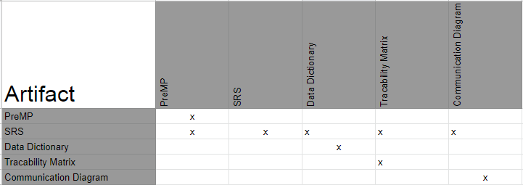

## 8.2 Product Strategies

To be determined

## 8.3 Analysis Metrics to be Used

* LOC
* Function Points
* Hours

## 8.4 Development Phases

* Requirements & Specifications
* Storyboard
* Back-End Integration
* Implementation
* Working Prototype
* Client Sign-off

## 8.5 Deliverables

* Project Outline
* Group Member Availability Chart
* Weekly Status Report
* Bi-weekly Phone Conference
* Time Sheets
* Localized Prototype
* Full Prototype
* End Product

## 8.6 Example Screens/Reports

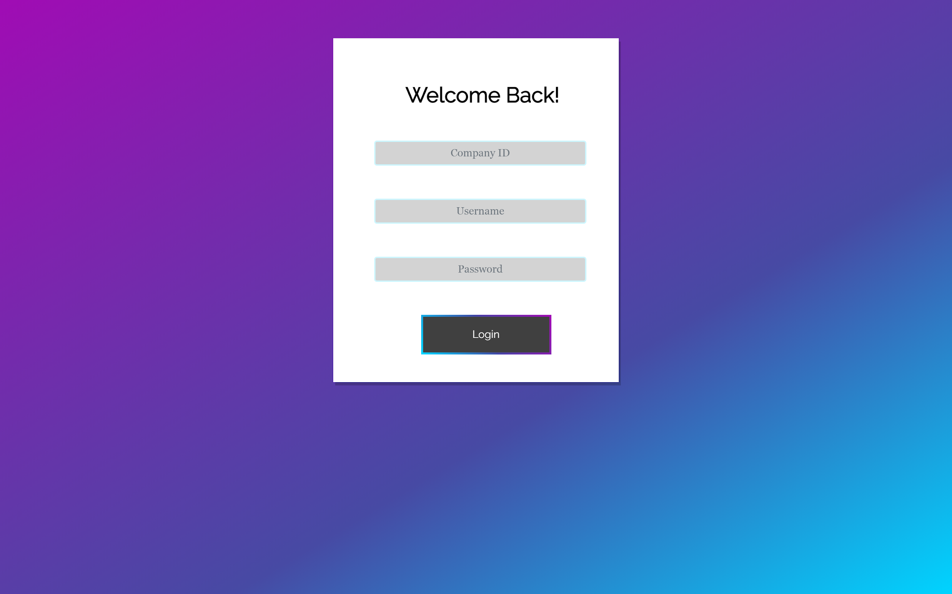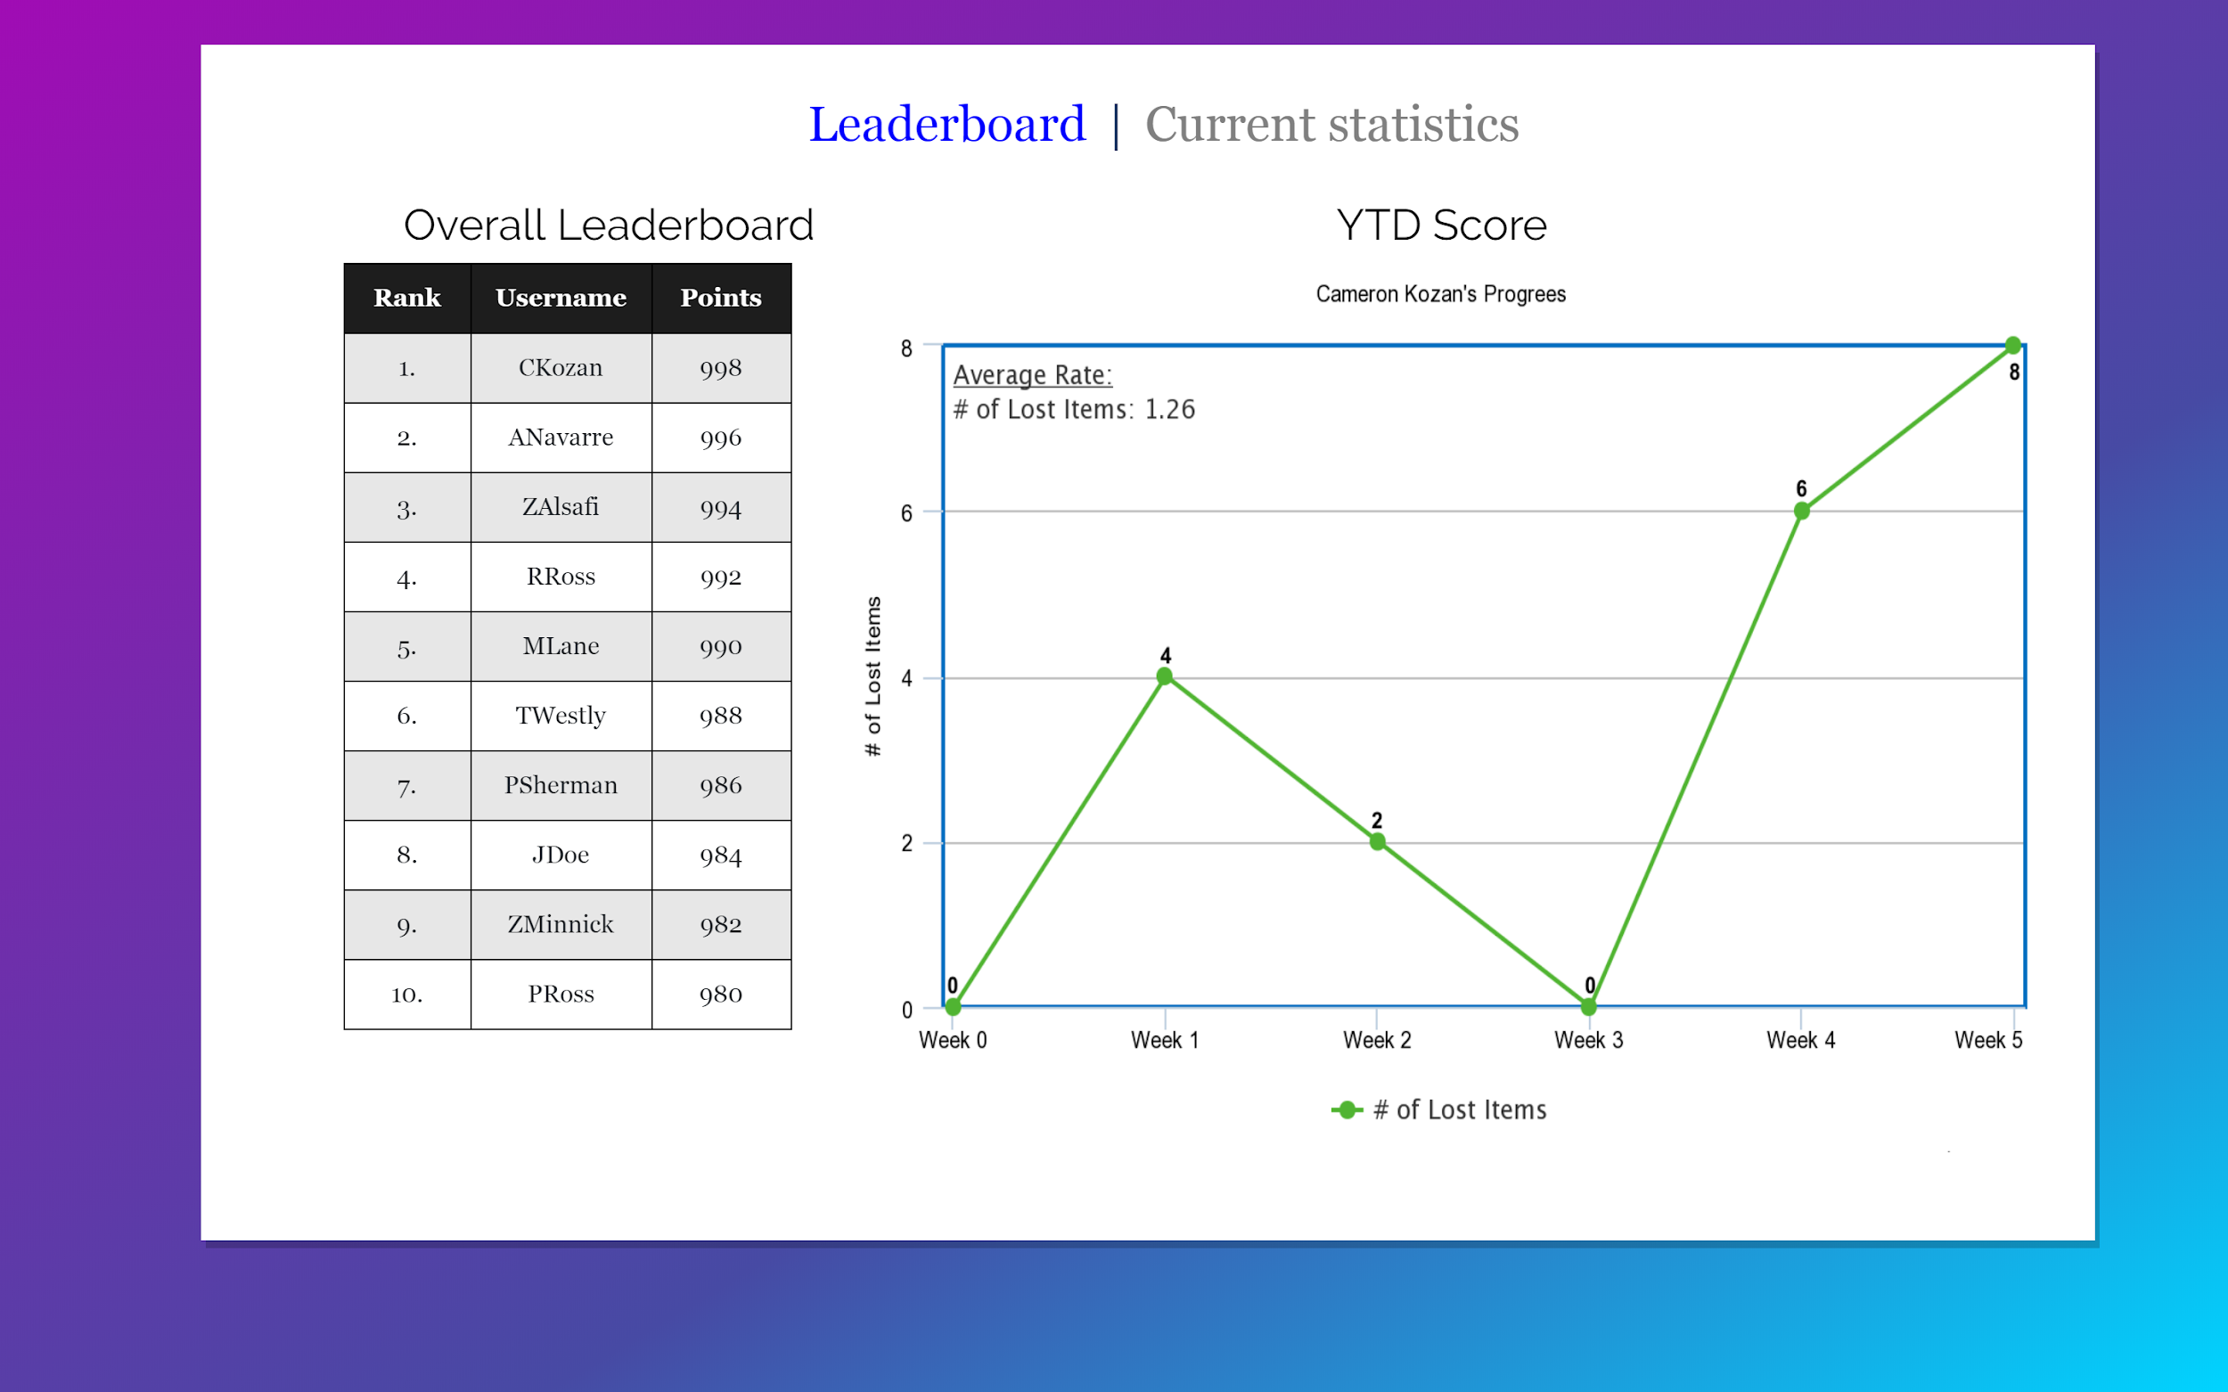

## 8.7 Report Format and Editorial Quality

* Weekly status report along with phone conference every other week. Group member availability will be updated weekly.
* Storyboarding will be used to match implementation methods with requirements with client.
* Requirements & Specification will be updated periodically to match clients requests

## 8.8 Supplementary Information

# 9.0 Signatures

|  |  |  |
| --- | --- | --- |
| Name | Role | Signature |
| Ryan Ross | Team Lead | **Ryan Ross** |
| Cam Kozan | Development | **Cameron Kozan** |
| Zaid Alsafi | Documentation Lead | **Zaid Alsafi** |
| Alex Navarre | Development |  |
|  |  |  |

